# Use Case Diagram

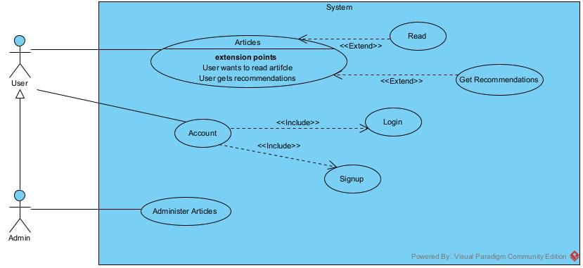

# Use Case Descriptions

**Use Case: Articles**

**Use case** : Articles

**Actors**: User, Admin

**Purpose**: Allow user to read articles if selected or to get recommended articles

**Overview**: The user can chose to view articles that are stored, and read them and interact with it(e.g., rate, like, skip articles). This information is stored in the system which is used to generate recommendations for the user.

**Pre-conditions**:

1. The user must be registered and logged into the system
2. The system must have an active storage connection with the system

**Post-conditions:**

1. The interactions must be successfully logged into the system

**Main Flow(Success Scenario)**

|  |  |
| --- | --- |
| **Actor** | **System** |
| 1. **Selects Articles** |  |
|  | 1. **Get Articles from storage** |
|  | 1. **Show list of Articles** |
| 1. **Selects Article to read** |  |
| 1. **Like the Article** |  |
|  | 1. **Record interaction in the system** |
|  |  |

**Alternative Flows**

**A1: Selects To Get Recommendation**

1. **System** retrieve users interactions from storage.
2. **System** produce recommendations based on past interactions with the user.

**A2: Storage Error**

1. System fails to connect to the **Storage** and retrieve/save data.
2. User gets error notification.

**A3: Other Interactions with the Article**

1. **User**  decides to skip the article, the interaction is recorded in the **Storage.**
2. **User** decides to rate the article, the interaction is recorded in the **Storage.**

**Use Case: Account**

**Use case** : Account

**Actors**: User

**Purpose**: To allow user to login to the System

**Overview**: System allows the users to enter login details to allow access to the system.

**Pre-conditions**:

1. The storage is connected to the System successfully.

**Post-conditions:**

**Main Flow(Success Scenario)**

|  |  |
| --- | --- |
| **Actor** | **System** |
| 1. **Start Session** |  |
|  | 1. **Prompt for login details** |
| 1. **Enters login details** |  |
|  | 1. **Validate with storage** |
| 1. **Receive confirmation** |  |

**Alternative Flows**

**A1: Invalid Input**

1. The **System** recognizes the invalid input .
2. **System** display the error message.

**A2: User Decide to Signup**

1. The **System** checks whether credentials are valid.
2. The **System** records the user’s credentials in the storage.

**A3: Storage Error**

1. **System** fails to connect to storage and save/retrieve data.
2. **User** gets error message.

**Use Case: Account**

**Use case** : Account

**Actors**: Admin.

**Purpose**: Allows admin to login into the system.

**Overview**: The use case allows the admin to enter login details, which allows the admin into the system.

**Main Flow(Success Scenario)**

|  |  |
| --- | --- |
| **Actor** | **System** |
| 1. **Start session** |  |
|  | 1. **Prompt for login details** |
| 1. **Enter login details** |  |
|  | 1. **Validate login details** |
| 1. **Receive confirmation** |  |

**Alternative Flows**

**A1: Invalid Input**

1. The **System** recognizes the invalid input.
2. **System** display the error message.

**A2: Storage Error**

1. **System** fails to connect to storage and save/retrieve data.
2. **Admin** gets error message.

**Use Case: Administer Articles**

**Use case** : Account

**Actors**: Admin

**Purpose**: Allows admin to **publish Articles.**

**Overview**: Allows the **Admin** to publish articles into the system. The new article will be stored inside and will be able for the users when they login.

**Pre-conditions:**

1. Admin must be registered and logged into the system.
2. The System storage connection must be active to save the added articles.

**Post-conditions:**

1. The data is successfully logged into the system

**Main Flow(Success Scenario)**

|  |  |
| --- | --- |
| **Actor** | **System** |
| 1. **Selects to publish articles** |  |
|  | 1. **Prompt admin to add the article details** |
| 1. **Enter article to be published** |  |
|  | 1. **Stores the article in the storage** |
| 1. **Receive confirmation** |  |

**Alternative Flows**

**A1: Storage Error**

1. System fails to connect to **Storage** and save the data.
2. **System** display an error message.

# Activity Diagrams

**User Article**

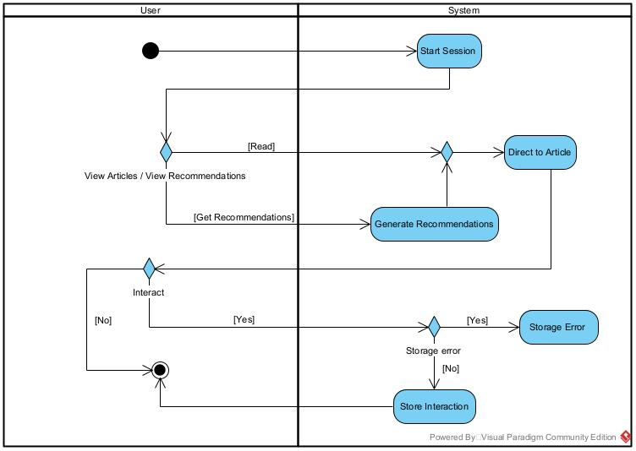

**User Account**

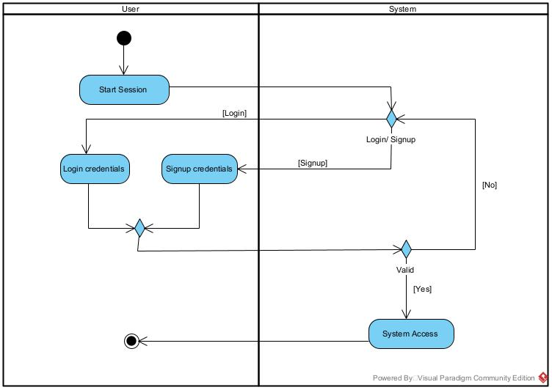

**Admin Account**

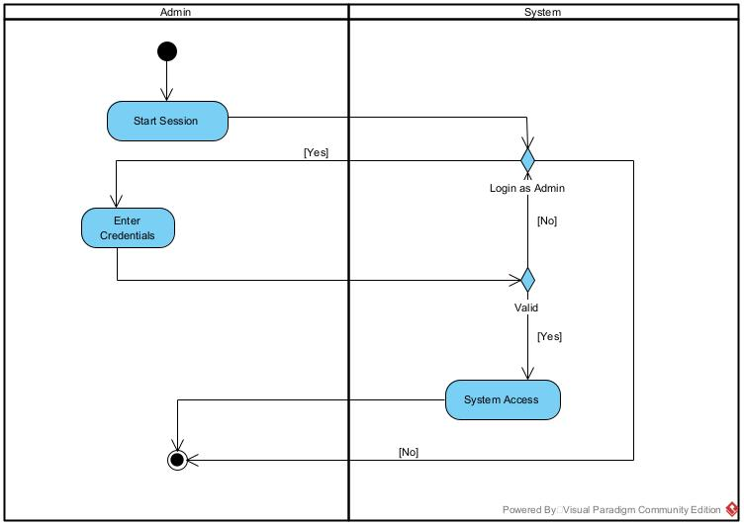

**Admin Administer Article**

